MONTGOMERY CHAPTER – AGA

ACCOUNTING

SCHOLARSHIP

APPLICATION

DEADLINE APRIL 6, 2012

MONTGOMERY CHAPTER – AGA
SCHOLARSHIP
STATE EMPLOYEE
Deadline April 6

GENERAL QUALIFICATIONS:

The Montgomery Chapter of the Association of Government Accountants announces the availability of scholarships for the upcoming academic year in the amount of $1,000 and $500 to a full-time State employee.

The scholarship values are $1,000 and $500 for full-time student or part-time student.

Undergraduate Student Qualifications:

- The applicant must be an accounting major with an interest in government accounting.
- The applicant must have obtained a junior standing by the upcoming fall term.
- The applicant must have completed Intermediate Accounting I (or equivalent) and have declared accounting as his or her major course of study.
- The applicant must have at least one term of study remaining as of May 1 of current year.
- The applicant must be a full-time or part-time student as determined by the university requirements.
- The applicant must have a minimum overall grade point average of 2.0 on a 3.0 scale or 3.0 on a 4.0 scale.
- The applicant must be a legal resident of Alabama and a citizen of the United States.

Graduate Student Qualifications:

- The applicant must have earned an undergraduate degree in accounting or a concentration in accounting as defined by the Alabama State Board of Accountancy.
- The applicant must be working toward one of the following: MBA, MPA, MIS, Masters Degree in Accounting or other closely related course of study.
- The applicant must be at least a part-time student as determined by university requirements.
- The applicant must have maintained an overall undergraduate grade point average of 2.0 on a 3.0 scale or 3.0 on a 4.0 scale.
- The applicant must be a legal resident of Alabama and a citizen of the United States.
MONTGOMERY CHAPTER – AGA
SCHOLARSHIP
CHAPTER MEMBER
Deadline April 6

GENERAL QUALIFICATIONS:

The Montgomery Chapter of the Association of Government Accountants announces the availability of scholarships for the upcoming academic year in the amount of $1,000 and $500 to a member of the Montgomery Chapter of the Association of Government Accountants. The applicant must be a paid-up member of the Montgomery Chapter of the Association of Government Accountants and must have been a member for at least twelve (12) consecutive months prior to the scholarship application.

The scholarship values are $1,000 and $500 for full-time student or part-time student.

Undergraduate Student Qualifications:

- The applicant must be an accounting major with an interest in government accounting.
- The applicant must have obtained a junior standing by the upcoming fall term.
- The applicant must have completed Intermediate Accounting I (or equivalent) and have declared accounting as his or her major course of study.
- The applicant must have at least one term of study remaining as of May 1 of current year.
- The applicant must be a full-time or part-time student as determined by the university requirements.
- The applicant must have a minimum overall grade point average of 2.0 on a 3.0 scale or 3.0 on a 4.0 scale.
- The applicant must be a legal resident of Alabama and a citizen of the United States.

Graduate Student Qualifications:

- The applicant must have earned an undergraduate degree in accounting or a concentration in accounting as defined by the Alabama State Board of Accountancy.
- The applicant must be working toward one of the following: MBA, MPA, MIS, Masters Degree in Accounting or other closely related course of study.
- The applicant must be at least a part-time student as determined by university requirements.
- The applicant must have maintained an overall undergraduate grade point average of 2.0 on a 3.0 scale or 3.0 on a 4.0 scale.
- The applicant must be a legal resident of Alabama and a citizen of the United States.
MONTGOMERY CHAPTER – AGA
SCHOLARSHIP
CHILD OF CHAPTER MEMBER
Deadline April 6

GENERAL QUALIFICATIONS:

The Montgomery Chapter of the Association of Government Accountants announces the availability of scholarships for the upcoming academic year in the amount of $1,000 and $500 to a child of a member. The applicant’s parent must be a paid-up member of the Montgomery Chapter of the Association of Government Accountants and must have been a member for at least twelve (12) consecutive months prior to the scholarship application.

The scholarship values are $1,000 and $500 for full-time student or part-time student.

Undergraduate Student Qualifications:
- The applicant must be an accounting major with an interest in government accounting.
- The applicant must have obtained a junior standing by the upcoming fall term.
- The applicant must have completed Intermediate Accounting I (or equivalent) and have declared accounting as his or her major course of study.
- The applicant must have at least one term of study remaining as of May 1 of current year.
- The applicant must be a full-time or part-time student as determined by the university requirements.
- The applicant must have a minimum overall grade point average of 2.0 on a 3.0 scale or 3.0 on a 4.0 scale.
- The applicant must be a legal resident of Alabama and a citizen of the United States.

Graduate Student Qualifications:
- The applicant must have earned an undergraduate degree in accounting or a concentration in accounting as defined by the Alabama State Board of Accountancy.
- The applicant must be working toward one of the following: MBA, MPA, MIS, Masters Degree in Accounting or other closely related course of study.
- The applicant must be at least a part-time student as determined by university requirements.
- The applicant must have maintained an overall undergraduate grade point average of 2.0 on a 3.0 scale or 3.0 on a 4.0 scale.
- The applicant must be a legal resident of Alabama and a citizen of the United States.

MONTGOMERY CHAPTER – AGA
ACCOUNTING SCHOLARSHIP
Deadline April 6, 2012

The Montgomery Chapter of the Association of Government Accountants announces the availability of scholarships for the upcoming academic year in the amount of $1,000 and $500.

QUALIFICATIONS:

- The applicant must be an accounting major with an interest in government accounting.
- The applicant must have obtained at least a junior standing by the upcoming fall term.
- The applicant must have completed Intermediate Accounting I (or equivalent) and have declared accounting as his or her major course of study.
- The applicant must have at least one term of study remaining as of May 1 of the current year.
- The applicant must be a full-time or part-time student as determined by the university requirements.
- The applicant must have a minimum overall grade point average of 2.0 on a 3.0 scale or 3.0 on a 4.0 scale
- The applicant must be a legal resident of Alabama and a citizen of the United States.

Completed Application Form, Written Statement and Official Transcript from your university must be received by April 6 of current year to be considered for upcoming academic year.
MONTGOMERY CHAPTER
ASSOCIATION OF GOVERNMENT ACCOUNTANTS
SCHOLARSHIP APPLICATION

Name:
Campus Address:
Campus Telephone:
Home Address:
Home Telephone:
Classification for upcoming fall term:
Term in which applicant completed Intermediate Accounting I (or equivalent):
Grade Point Average and Scale:
Is applicant a full-time student?
Credit hours planned for next term (specify semester hours)
Is applicant a legal resident of Alabama (state residency in years/months):
NOTE TO APPLICANT:
Your written statement, in fifty (50) words or less, giving the reason you are applying for this scholarship and indicating your interest in government must accompany this application. The completed application, written statement, and official transcript (mailed by your university) must be received by April 6. Mail to: Association of Government Accountants, Kay Wilson, Scholarship Committee Chair, P. O. Box 1001, Montgomery, Alabama 36101.
Name:
Signature:
Social Security Number:
Date:

MONTGOMERY CHAPTER
ASSOCIATION OF GOVERNMENT ACCOUNTANTS
SCHOLARSHIP APPLICATION
FULL-TIME STATE EMPLOYEE

Name:
Employer and Address:
Address:
City, State, Zip:
Telephone:
Classification for upcoming fall term:
If Graduate, date undergraduate degree received or date of concentration in accounting was completed:
Major: |  |  |  |  |  |  |  | Grade Point Average & Scale:
Graduate Applicants - Source of Graduate Study Planned:
Term in which applicant completed Intermediate Accounting I (or equivalent):
Is applicant a full-time student?
Credit hours planned for next term (specify semester hours)
Is applicant a legal resident of Alabama (state residency in years/months):
NOTE TO APPLICANT:
Your written statement, in fifty (50) words or less, giving the reason you are applying for this scholarship and indicating your interest in government must accompany this application. The completed application, written statement, and official transcript (mailed by your university) must be received by April 6. Mail to: Association of Government Accountants, Kay Wilson, Scholarship Committee Chair, P. O. Box 1001, Montgomery, Alabama 36101.
Name:
Signature:
Social Security Number:
Date:
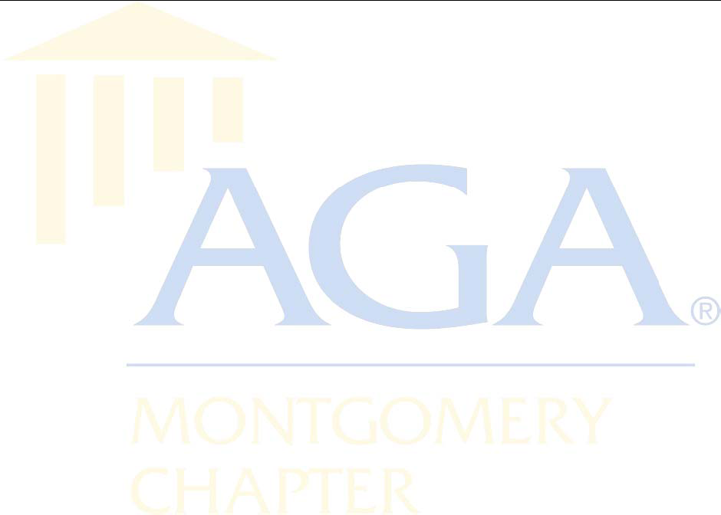
MONTGOMERY CHAPTER
ASSOCIATION OF GOVERNMENT ACCOUNTANTS
SCHOLARSHIP APPLICATION
CHAPTER MEMBER OR
CHILD OF CHAPTER MEMBER
Name:
Chapter Member’s Name:
Address:
City, State, Zip:
Telephone:
Classification for upcoming fall term:
If Graduate, date undergraduate degree received or date of concentration in accounting was completed:
Major: |  |  |  |  |  |  |  |  | Grade Point Average & Scale:
Graduate Applicants - Source of Graduate Study Planned:
Term in which applicant completed Intermediate Accounting I (or equivalent):
Is applicant a full-time student?
Credit hours planned for next term (specify semester hours)
Is applicant a legal resident of Alabama (state residency in years/months):
NOTE TO APPLICANT:
Your written statement, in fifty (50) words or less, giving the reason you are applying for this scholarship and indicating your interest in government must accompany this application. The completed application, written statement, and official transcript (mailed by your university) must be received by April 6. Mail to: Association of Government Accountants, Kay Wilson, Scholarship Committee Chair, P. O. Box 1001, Montgomery, Alabama 36101.
Name:
Signature:
Social Security Number:
Date:

