Menu | May 18, 2018  Spring 2018 PDT
  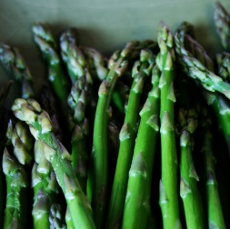  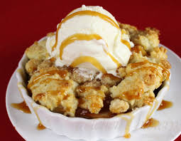  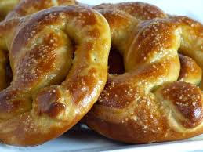 | All Star Breakfast  Scrambled eggs, bacon, grits, breakfast potatoes with peppers and onions, assorted fruits, chilled fruit juices, coffee, and herbal tea selection  Lunch – Home Style Buffet  Baked or fried chicken, garden salad, rolls, macaroni & cheese, green beans, rice, coffee, sweet/ unsweet tea, and water  Desserts  Banana pudding and peach cobbler  Afternoon Snack  Assorted potato chips, warm soft pretzels with mustard, assorted candy bars, cracker jacks, assorted soft drinks, and bottled water

All Day Coffee Service

